Hewan Teklu

Student ID # 2518543

**Wireshark Lab 4 – IP**

**IT 520-A – Enterprise Infrastructure & Networks.**

1. What is the IP address of your computer?

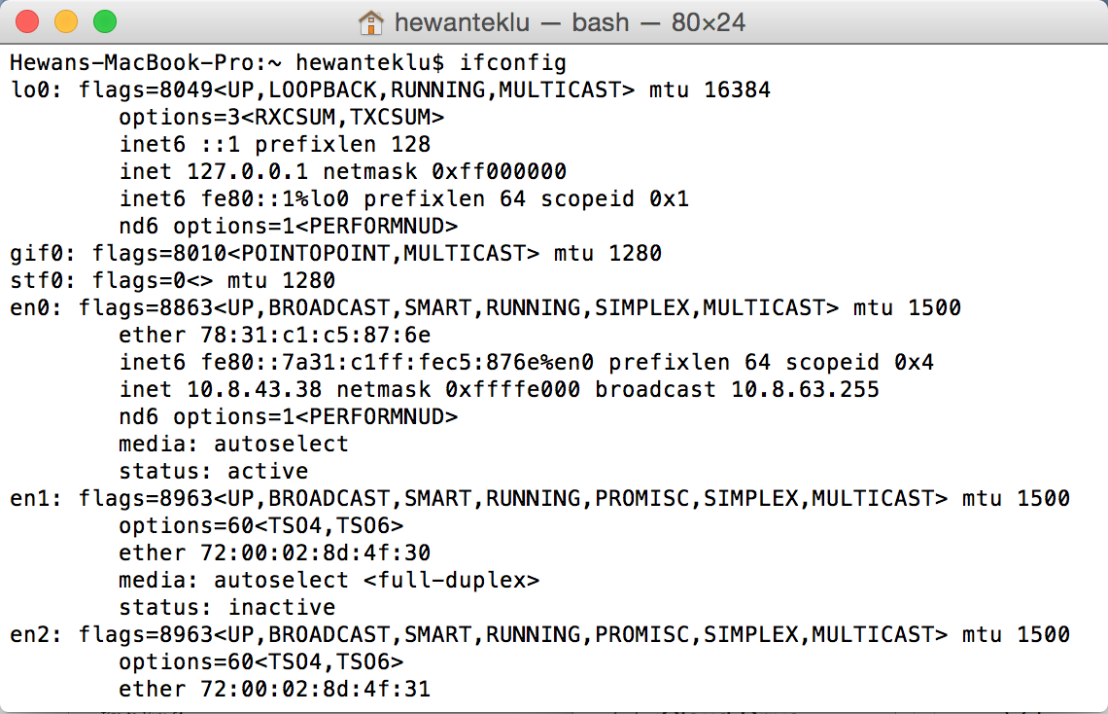

Solution:

**My computer IP Address is 10.8.43.38**

2. What is the total length of the datagram?

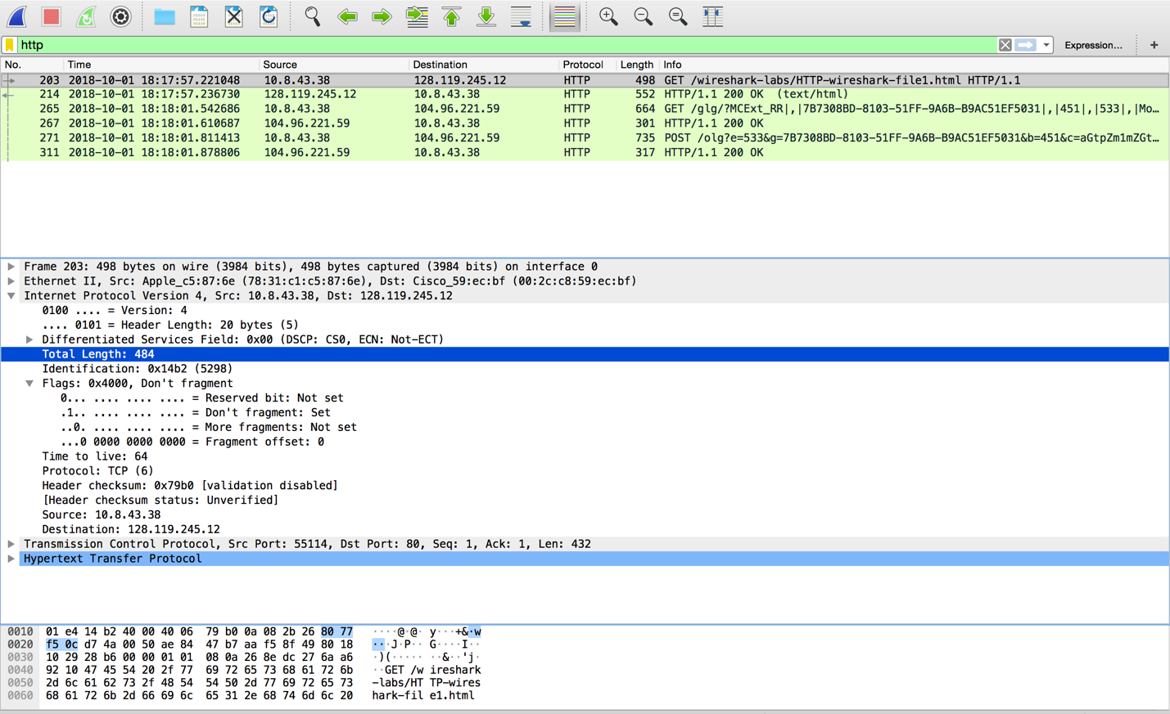

Solution:

**The total length of the datagram is 484**

3. Has this IP datagram been fragmented?



Solution:

**The more fragments bit = 0, so the data is not fragmented.**

4. How many bytes are in the IP header?



Solution:

**There are 20 bytes in the IP header.**

5. How many bytes are in the payload of the IP datagram? Explain how you determined the number of payload bytes.



Solution:

**There are 20 bytes in the IP header, and 484 bytes total length, this gives 464 bytes in the payload of the IP datagram.**

Explanation:

**484 bytes (total length) - 20 bytes (IP header length) = 464 bytes are in the payload of the IP datagram.**